

Type: | Bug | Priority: | Medium
Reporter: | Tomer Darmon | Assignee: | Unassigned
Environment: | Google Chrome  Version 124.0.6367.202 (Official version) (64 bit)  Microsoft Edge  Version 124.0.2478.97 (Official build) (64-bit)

[PPJP-52] Writing only one letter and see how it will affect the name text box Created: 23/Aug/24 Updated: 23/Aug/24
Status: | To Do
Project: | Paws Paradise-Jira project

Attachments: | 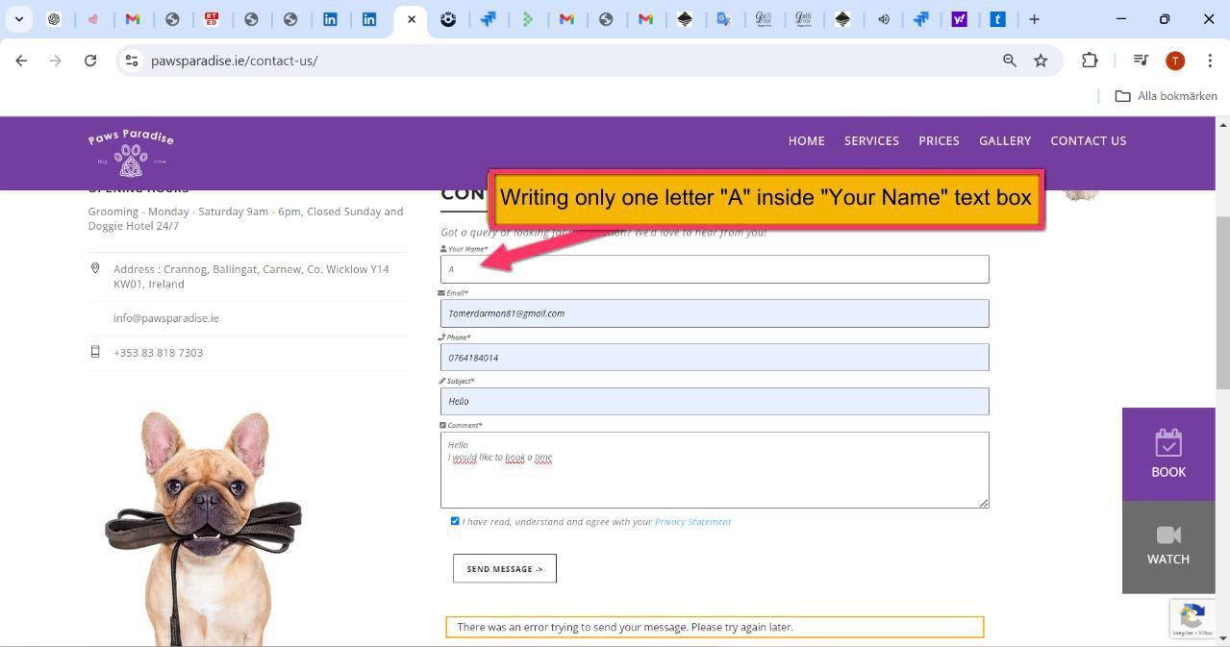
Severity1: | S3-Major

Description
Steps to Reproduce :
- Enter the website: https://www.pawsparadise.ie/contact-us/
- Scroll down the page until you reach "Your Name" text box
- Press in the text box only one letter: "A"
- Fill in the form and submit the form
Actual Result :
I don´t get any notification error regarding the specific area, only a general message that the site can’t go forward but not because of the bug i created
Expected Result :
I will expect that after writing only one letter "A", i will receive an error message that will tell me to write a full name or a valid name

71

